SAÉ1.05
Acia CHOUCHANE

User manual for the analysis program :

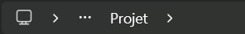 | The text file to be analyzed must be in the "Projet" folder and should not contain any accents or spaces.
In the software that will open the program, you must open the folder containing the "Projet" folder.
Example: If the text file to be processed is located at: C:\Desktop\Projet\file.txt
Then the software will open the folder: C:\Desktop

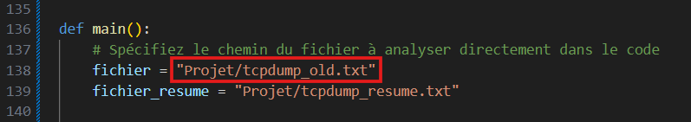 | Now open the program: Traitement_text.py  On line 138, modify the name of the file to be named : "Projet/new_name.txt"
Finally, run the program.
It will create a text file "tcpdump_resume.txt" that will contain all the important lines from the file to be analyzed.
Then it will sort the important data from the file and save it in "adressses_extraites.csv".
Finally, it will analyze the data that seems similar, compile it, and save it in a markdown file, which will then be converted to HTML. The most important information will be displayed in "compte_rendu.html".

